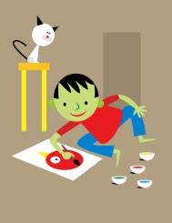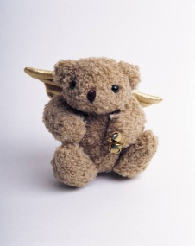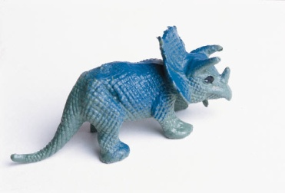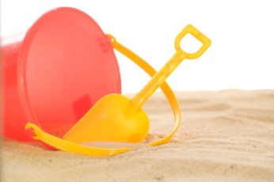
WHAT IS PLAY THERAPY?

Play therapy is to children what counseling is to adults. Play therapy utilizes play, children's natural medium of expression, to help them express their feelings more easily through toys instead of words.
“The main posit of play therapy is the belief that children are able to self-actualize through play when in an accepting environment.” Virginia Axline (1947)

Children have strengths that we cannot imagine. Play therapy gives them a place to discover these strengths and learn to use them to build resilience and recovery. Traumatized children especially feel they have no power and not outlet for their pain and feelings. Play therapy can look like ‘just play’ to the outsider, but with a trained play therapist it is a time and place to be accepted no matter how the child feels. The real word has expectations of following the rules like, no talking in line, color in the lines, if you hit someone you go to time out and act like other children. In the play room a child can be who they want to be and acknowledge their feelings.
Through play therapy, children learn to communicate with others, express feelings, modify behavior, develop problem-solving skills, and learn a variety of ways of relating to others. Play provides a safe psychological distance from their problems and allows expression of thoughts and feelings appropriate to their development.
Association for Play Therapy (APT) defines play therapy as "the systematic use of a theoretical model to establish an interpersonal process wherein trained play therapists use the therapeutic powers of play to help clients prevent or resolve psychosocial difficulties and achieve optimal growth and development."
Play therapy: The art of the relationship Landreth (2002)
A dynamic interpersonal relationship between a child (or person of any age) and a therapist trained in play therapy procedures who provides selected play materials and facilitates the development of a safe relationship for the child (or person of any age) to fully express and explore self (feelings, thoughts, experiences, and behaviors) through play, the child's natural medium of communication, for optimal growth and development.

WHO BENEFITS FROM PLAY THERAPY?
Children from ages 18 months to about age 12 are optimal, but older children can sometimes benefit from play therapy as well as families and adults. Terri Liticker LCSW RPT-S sees children from about 18 months up. Some children are developmentally appropriate for play therapy into their teen years.

HOW DOES PLAY THERAPY BENIFIT A CHILD
Children may achieve the following benefits
- Become more responsible for behaviors and develop more successful strategies.
- Develop new and creative solutions to problems.
- Develop respect and acceptance of self and others.
- Learn to experience and express emotion.
- Cultivate empathy and respect for thoughts and feelings of others.
- Learn new social skills and relational skills with family.
- Develop self-efficacy and thus a better assuredness about their abilities.
- Become more independent

